Bluetooth Keyboard
Your ideal tablet, smartphone or notebook portable wireless keyboard

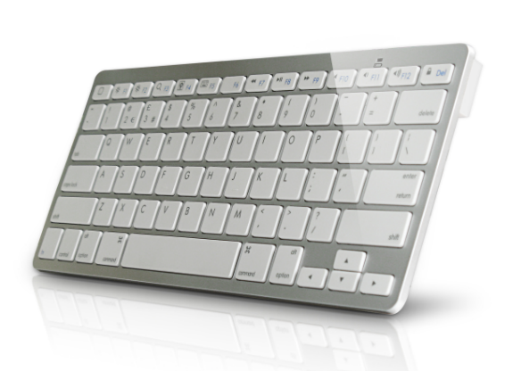

Descrption:

More than just good looks..

Tablet computers and smartphones allow us to communicate in an easy and instant way but we are too often hindered by the slow and awkward response of the touch-screen keyboard. Not ideal for fast typers, as its often frustrating when we hit the wrong keys.

The KBD-BT-S is your ideal BluetoothTM wireless keyboard partner for all tablet computers, including iPadTM iPad MiniTM and iPhoneTM and of course the iMacTM and MacBookTM range of computers. Using the common Mac OS multimedia shortcut keys allows you to control your computer whenever you want. Of course, other Operating Systems have not been overlooked since both WindowsTM and AndroidTM computing devices are also supported.

Plug and play simplicity is assured. Using the latest BluetoothTM version 3.0 technology allows the KBD-BT-S to be easily and securely paired with your tablet, smartphone or notebook in an instant and proven BluetoothTM functionality means you can enjoy a totally wire-free experience of up to 10 metres. Ideal on the move, in the office or in the living room, the KBD-BT-S is your ideal BluetoothTM wireless partner for all your computing devices.

Features:

MacTM OS command and Fn key functionality

Ideal for MacTM OS X or iOSTM specific applications and control.
The ideal keyboard partner for MacTM, WindowsTM and AndroidTM
Fully compatible with other hardware and operating systems. Ideal for users using multiple hardware platforms. Ideal also for media centres that support the BluetoothTM HID standard.
Battery power that goes the distance
Powered by two AAA batteries (user supplied), they allow many weeks
of typing wirelessly and offer built-in power management to get the most out of your batteries*
BluetoothTM wire-free convenience
No messy USB keyboards to plug in. No USB adapters to plug into your non USB tablet or smartphone. Just pair the keyboard with your Bluetooth device and start typing straight away.
Fast typing with tactile feedback
Full-travel quality keys allow fast and accurate typing. Angled keyboard design helps reduce wrist strain on extended use.

Specifications
- material :ABS material
- Cable length(outer part)：wireless
- Product Compatibility：iOS, Android, Windows
- Version：BT 3.0
- Operation Style：Scissor
- Type：Wired
- Drive Interface：BT 3.0
- Keyboard Standard：78 Keys
- Certificate: CE FCC ROHS
- Operating Temperature:0℃ to +45℃
- Operating Humidity:10%0 to 85 % RH
- Storage Temperature : -10℃ to +55℃
- Storage Humidity: 5% to 90 % RH

Product Code:
Part number: KBD-BT-S
Barcode: 8400800022509
Size: 285.5*120.5*18 mm
Weight: 0.175 kg

